SELECT

patient_2.patient_id patient_id,

patient_2.patient_firstname patient_firstname,

patient_2.patient_lastname patient_lastname,

patient_2.patient_email,

patient_visit_2.patient_id patient_visit,

patient_visit_date

FROM

patient_2

INNER JOIN patient_visit_2 ON patient_visit_2.patient_id = patient_2.patient_id

ORDER BY patient_visit_2.patient_visit_date ASC;

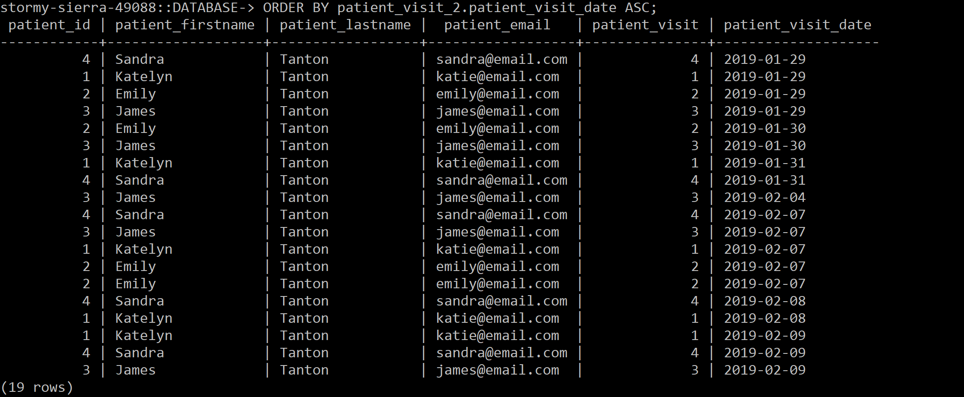

SELECT

patient_2.patient_id patient_2_id,

patient_2.patient_firstname patient_firstname,

patient_2.patient_lastname patient_lastname,

patient_2.patient_email,

patient_visit_2.patient_id patient_visit_2_id,

patient_visit_date

FROM

patient_2

INNER JOIN patient_visit_2 ON patient_visit_2.patient_id = patient_2.patient_id

ORDER BY patient_2.patient_id ASC;

